**8.1 Structure of the Immune System**

Innate and Adaptive Immunity

1. Innate immunity = nonspecific immunity
   1. Defences always active against pathogens, but not capable of targeting specific invaders
2. Adaptive immunity = specific immunity
   1. Longer time to mount an attack, but response targets a specific pathogen and maintains immunological memory of the infection → faster response during subsequent infections

Anatomy

* Lymph nodes
  + Filter lymph
  + Site where immune responses can be mounted
* Bone marrow
  + Site of immune cell production
* Thymus
  + Site of T cell maturation
* Spleen
  + Storage area for blood
  + Filters blood and lymph
  + Site where immune responses can be mounted
* Gut-associated lymphoid tissue (GALT)
  + Tonsils
  + Adenoids
* Leukocytes
  + Granular (neutrophils, eosinophils, basophils)
  + Agranular (lymphocytes, monocytes)

|  |  |  |  |  |  |
| --- | --- | --- | --- | --- | --- |
| **Cell Type** | **Site of development** | **Site of maturation** | **Major Functions** | **Specific or nonspecific** | **Humoral or cell-mediated** |
| **B-cell** | Bone marrow | Bone marrow (but are activated in spleen or lymph nodes) | Produce antibodies | Specific | Humoral |
| **T-cell** | Bone marrow | Thymus | Coordinate immune system and directly kill infected cells | Specific | Cell-mediated |

**8.2 The Innate Immune System**

Noncellular Nonspecific Defenses

* The **skin** acts as a physical barrier and secretes antimicrobial compounds e.g. **defensins**
* **Mucus** on mucous membranes traps pathogens; in the respiratory system, the mucus is propelled upwards by cilia and can be swallowed or expelled
* Tears and saliva contain **lysozyme**, an antibacterial compound
* The stomach produces **acid**, killing most pathogens. **Colonization** of the gut helps prevent overgrowth by pathogenic bacteria through competition
* The **complement** system can punch **holes** in the cell walls of bacteria, making them **osmotically** unstable
  + Classical pathway (which requires the binding of an antibody to a pathogen)
  + Alternative pathway (which does not require antibodies)
* **Interferons** are given off by virally infected cells and help prevent viral replication and dispersion to nearby cells

Cells of the Innate Immune System

* **Macrophages** ingest pathogens and present them on **major histocompatibility complex (MHC)** molecules. They also secrete **cytokines.**
* **MHC-I** is present in all nucleated cells
  + Displays **endogenous antigen** (proteins from within the cell) to cytotoxic T-cells (CD8+ cells)
* **MHC-II** is present in professional antigen-presenting cells (macrophages, dendritic cells, some B-cells, and certain activated epithelial cells)
  + Displays **exogenous antigen** (proteins from outside the cell) to helper T-cells (CD4+ cells)

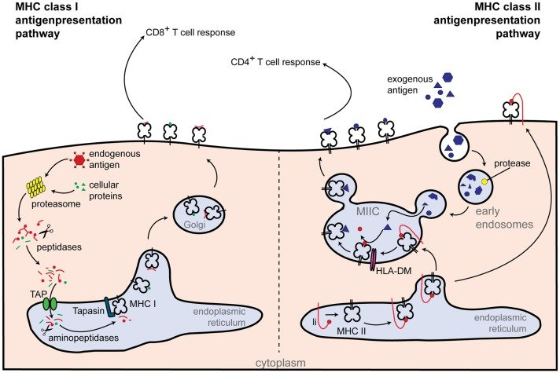

* Macrophages
  + Engulfs and **consumes pathogens**
  + **Produce appropriate cytokines** for correct recruitment of immune cells
* Natural killer (NK) cells → nonspecific
  + Activated by cells that do not present MHC (esp virally infected cells and cancer cells)
  + Able to **detect the downregulation of MHC** and induce apoptosis in **virally infected cells**
  + Some cancer cells may also downregulate MHC production → cannot be detected by T-cells, but can be detected by NK cells
* Granulocytes → nonspecific inflammatory response
  + Neutrophils
    - Most populous leukocyte, and are very short-lived (less than 5 days)
    - Phagocytic → target **bacteria**; follow using chemotaxis
    - Can also detect bacteria once they have been opsonized
    - Dead neutrophil collections → pus formation
  + Eosinophils
    - Contain bright red-orange granules, and are primarily involved in **allergic reactions** and **invasive parasitic** infections
    - Release large amounts of **histamine** upon activation → vasodilation + leaky blood vessels → more immune cells (esp macrophage and neutrophils) move out of blood into tissue
  + Basophils
    - Least populous leukocyte under normal conditions
    - Contain large purple granules, and involved in **allergic reactions**
    - Closely related to mast cells (which have smaller granules)
      * Both release large amounts of histamine in response to **allergens**

**8.3 The Adaptive Immune System\***

* Humoral immunity
* Cell-mediated (cytotoxic) immunity

Cells of the Adaptive Immune System

1. **Humoral Immunity** is centered on antibody production by plasma cells (which are activated B cells)
   1. Antibodies target a particular antigen
      1. Two heavy chains and two light chains (each has a constant and a variable region)
      2. The tip of the **variable region** is the **antigen-binding site**
      3. When activated, the antigen-binding site undergoes **hypermutation** → improve specificity of the antibody produced i.e. switching isotypes of antibody (IgM, IgD, IgG, IgE, IgA)
   2. Two types of antibodies
      1. Antibodies secreted into body fluids → 3 possibilities:
         1. **Opsonization:** Once bound to a specific antigen, antibodies may attract other leukocytes to phagocytize those antigens immediately
         2. **Agglutination:** Cause pathogens to clump together→ form large insoluble complexes that can be phagocytized
         3. **Neutralization:** Block the ability of a pathogen to invade tissues
      2. Cell-surface antibodies
         1. **B-cells:** Binding of antigen activates it → proliferation and formation of plasma and memory cells
         2. **Mast cells:** Binding of antigen leads to degranulation (exocytosis of granule contents) → release of histamine → inflammatory allergic response
2. **Cytotoxic Immunity** is centered on the functions of T-cells
   1. T-cells undergo maturation in the thymus (promoted by thymosin) through:
      1. Positive selection (only selecting for T-cells that can react to antigen presented on MHC)
      2. Negative selection (causing apoptosis in self-reactive T-cells)
   2. Four types:
      1. Helper T-cells (Th or **CD4+**)
         1. Respond to antigen on **MHC-II** and coordinate the rest of the immune system, secreting **lymphokines** to activate various arms of immune response
            1. Th1 cells secrete interferon gamma → **activate macrophage**
            2. Th2 cells **activate B cells** → **parasitic infections**
      2. Cytotoxic T-cells (Tc, CTL or **CD8+**)
         1. Respond to antigen on **MHC-I** and kill **virally infected cells**
      3. Suppressor (or regulatory) T-cells (Treg)
         1. Tone down the immune response
         2. Promote **self-tolerance** → turn off self-reactive lymphocytes to prevent auto-immune disease
      4. Memory T-cells
         1. Similar function to memory B-cells

Activation of the Adaptive Immune System

* Five types of infectious pathogens: bacteria, virus, parasites (including protozoa, worms, and insects), and prions (for which there are no immune defenses)
* The two most common types are shown below:

1. Bacterial (extracellular) infections
   1. Bacteria enters body via laceration
   2. Macrophages (and other antigen-presenting cells) engulf the bacteria and then release inflammatory mediators + digest bacteria and present antigen with MHC-II
   3. The cytokines attract inflammatory cells, including neutrophils and additional macrophages
   4. Mast cells are activated by the inflammation → degranulation → histamine release + leaky capillaries → more immune cells leave the bloodstream and enter affected tissue
   5. Dendritic cell leaves the affected tissue → travel to the nearest lymph node → activate B-cells
      1. B-cells that produce the correct antibody proliferate through clonal selection → more plasma cells and memory cells
      2. Antibodies travel through the bloodstream to the affected tissue → target the bacteria for destruction
   6. Dendritic cells also present the antigen to CD4+ T-cells → T-cell response
      1. Th1 cells release interferon gamma → activates macrophages → can kill more bacteria
      2. Th2 cells help activate B cells and are more common in parasitic infections
   7. After the pathogen has been eliminated, plasma cells die, but memory B- and T- cells remain
2. Viral (intracellular) infections
   1. Virus infect cells → virally infected cells start to produce interferons
      1. Reduce permeability of nearby cells (decrease the ability of the virus to infect these cells)
      2. Reduce rate of transcription and translation in these cells (decrease the ability of the virus to multiply)
   2. Present intracellular proteins with MHC-I
   3. Antigen complex recognized by CD8+ cells
      1. Inject toxins into the cell to promote apoptosis
   4. If the virus downregulates the production and presentation of the MHC-I molecules, NK cells will recognize the absence → cause apoptosis
   5. Once pathogen has been cleared, memory T-cells will be generated

Recognition of Self and Nonself

* In **autoimmune** conditions, a self-antigen is recognized as foreign, and the immune system attacks normal cells
* In **allergic** reactions, nonthreatening exposures incite an inflammatory response

Immunization

1. **Active immunity**: **immune system is stimulated** to produce antibodies against a specific pathogen
   1. Natural: Antibodies are generated by B-cells once an individual becomes infected
   2. Artificial: Through vaccination
2. **Passive immunity**: **transfer of antibodies** to an individual (**transient** because only the antibodies, and not the plasma cells that produce them, are given to them)
   1. Natural: Across the placenta during pregnancy; through breast milk to nursing infant
   2. Artificial: Intravenous immunoglobulin (Ig) given to prevent pathogen from spreading e.g. rabies virus, tetanus

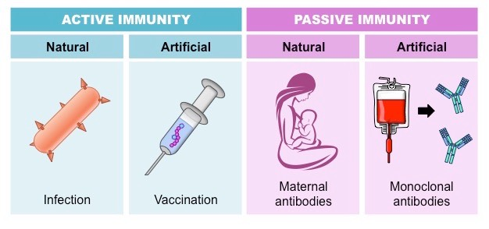

**8.4 The Lymphatic System**

* B cells proliferate and develop within the lymphatic system

Structure

* A type of circulatory system made of one-way vessels that become larger as they move toward the centre of the body
* Vessels carry lymphatic fluid (lymph) → most join to comprise a large **thoracic duct** in the posterior chest → delivers the fluid into the **left subclavian vein** (near the heart)
* Lymph nodes are small, bean-shaped structures along the lymphatic vessels
  + Contain a lymphatic channel, an artery and a vein
  + Provide a space for the cells of the immune system to be **exposed to possible pathogens**

Function

1. **Equalization of Fluid Distribution**
   1. Net pressure drawing fluid in at the venule end << net pressure pushing fluid out at the arterial end → small fluid remains in the tissues → drained into lymphatic vessels → fluid later returned into the bloodstream
2. Transportation of Biomolecules
   1. Transports fats from the digestive system into the bloodstream
   2. Lacteals (small lymphatic vessels) are located at the centre of each villus in the small intestine
      1. Fats packaged into chylomicrons by intestinal mucosal cells → enter the lacteal for transport
      2. Lymphatic fluid + many chylomicrons = chyle (milky white appearance)
3. Immunity
   1. Lymph nodes are a place for antigen-presenting cells and lymphocytes to interact
   2. B cells proliferate and mature in the lymph nodes in collections (germinal centres)